  - “Just another flash in the pan”

Lock Maintenance
Larry “Longarm” Walker #1884H
“Period correct” is a favorite topic of debate and discussion among folks like us. Is his camp right? What about that hat? Would a trapper carry that? What about his firearms?
Proper maintenance of your firearms lock is in my mind one of the most important and often overlooked pieces of equipment of a mountaineer. Your firearm is what fed you, clothed you and protected you. It is said that upon returning to camp a hunter would attend to his horse, gun , then to himself, I’ve seen men in camp with a well picketed and watered horse feeding himself and a filthy gun! ‘Nuff said.
I claim no expertise, there are many who know far more than me about flinters. I’m simply sharing a few things that I’ve learned over the years from others and my own experience.
Your lock should be removed from your gun, cleaned inspected and oiled regularly, I remove mine every time I clean my rifle, it just makes it easier to clean the lock and touch hole (we will talk in future writings about modern and period methods of cleaning). Disassembly of the lock is not necessary or recommended unless there is a functionality problem. I only disassemble a lock in the field if I’m teaching a “college” or working on a neglected or malfunctioning gun. The first thing I do with an antique gun I have purchased to shoot is to remove and service the lock at home in the shop.
To clean your lock, I have found nothing better than hot soapy water and an old tooth brush. I have an air compressor, so I can blow it dry, but you can set it in the sun or near a heat source. When dry all that is needed is to lubricate everywhere there is metal to metal contact, I use sperm oil from way back that I was able to find. Any light oil will work even a light coat of an aerosol like Rem Oil for the inside; don’t get in the pan or on the frizzen. Wipe any excess off and I apply beeswax along the edge of the lock plate to lubricate it from the inlet. When reinstalling the lock don’t overtighten the lock screws, just make sure the pan bolster is seated tight up to the barrel. Over tightening the front lock screw particularly can warp the lock plate causing binding inside.
If you have determined that you need to disassemble your lock you will need good tight-fitting screwdrivers and a mainspring vice (I like Larry Callahan and Jim Chambers the best).
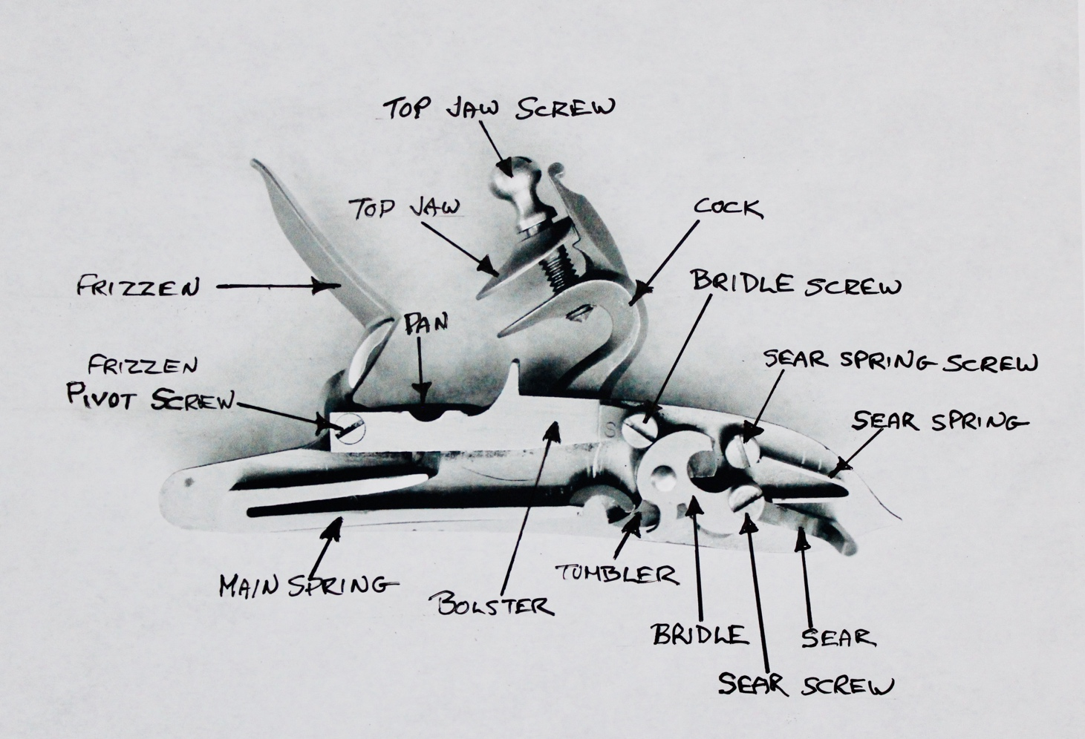

I proceed as follows:
1st Remove the main spring by putting the lock in full cock and using your vice to take up slack in the spring, this way you aren’t having to use the vice to compress the spring. Then decock the lock and wiggle the spring free. Leave the spring in the vice if you are going to put it back together soon, otherwise release the tension and let the spring relax. If your lock has a stirrup on the spring note its orientation before removal.
2nd Loosen the sear spring screw enough to rotate the spring off the sear, then remove it keeping the screw with the spring (a magnetic tray is perfect for all the parts and can be purchased cheap from a discount tool outfit)
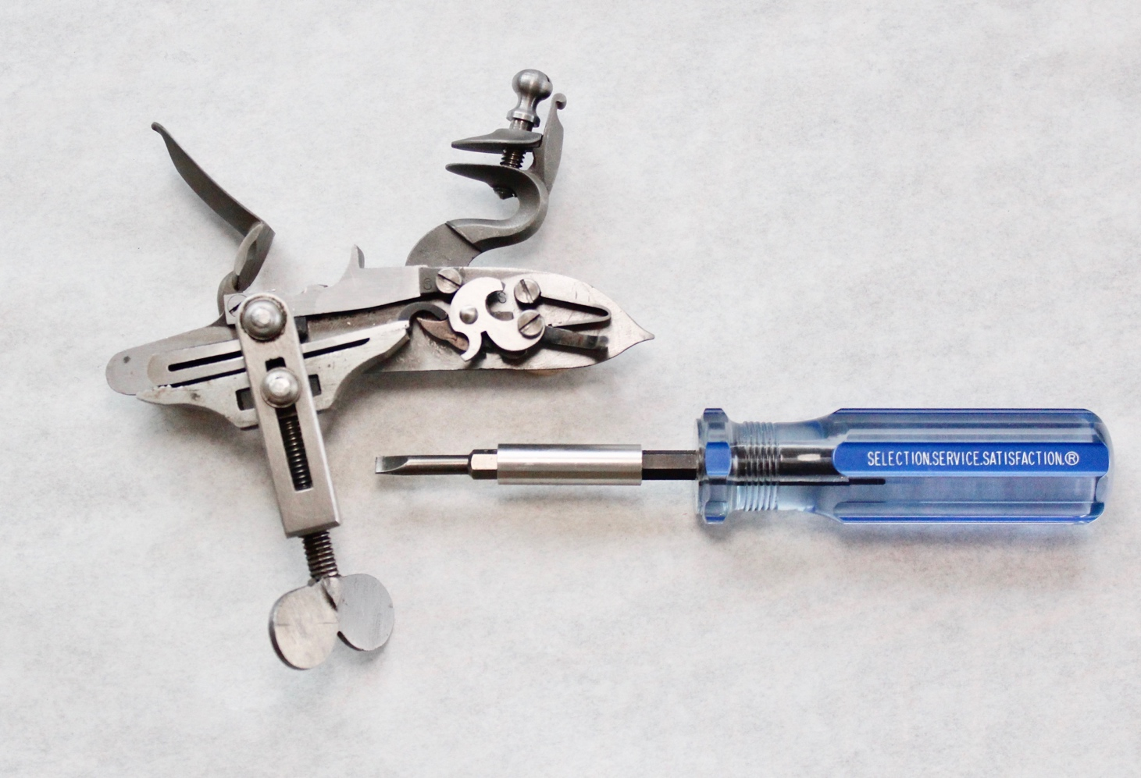
3rd Remove the sear and bridal screws keeping them with their parts. Be very careful not to lose the fly if your lock is equipped with one when removing the bridal.
4th Next I remove the frizzen spring by compressing it with the frizzen and using another spring vice or some small vice grips to hold it compressed, then remove the screw.
5th Usually removing the cock isn’t needed but to do so remove the cock screw then support the lock plate with a couple blocks of wood or an open vice. I use a small brass punch that fits easily inside the threads of the tumbler and gently tap it loose while holding my hand underneath to catch it. DO NOT PRY THE COCK OFF THE TUMBLER!
6th Again it usually isn’t necessary to remove the frizzen but it’s now just a matter of removing the screw
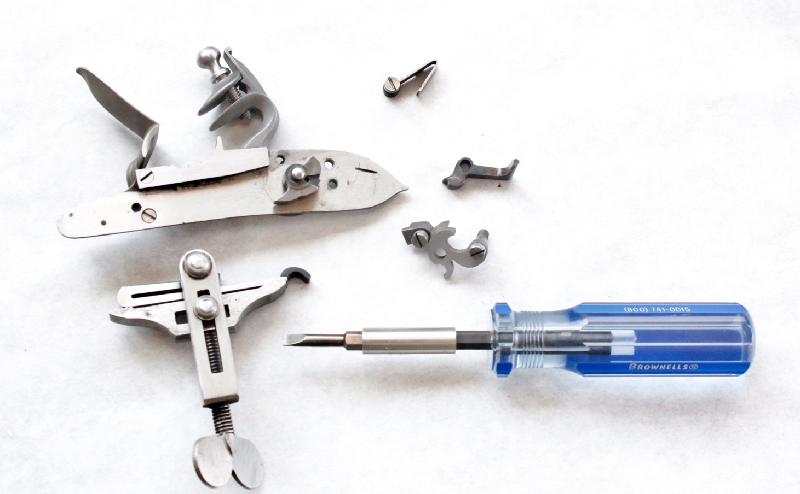
Reassembly is simply reversing the order. A few tips; don’t overtighten the cock screw, many locks use a 6-40 screw here which can be stripped easily, this screw should be checked regularly. The bridal screw should be nice and snug but the sear screw should just make contact with the bridal and then backed off a smidge. When reinstalling the sear spring, start the screw with the spring rotated away from the sear, then rotate it into its slot making contact with the sear and snug up the screw.
Good luck and good shooting!
If you have any questions or suggestions feel free to e-mail me at: longarm@nvbell.net

