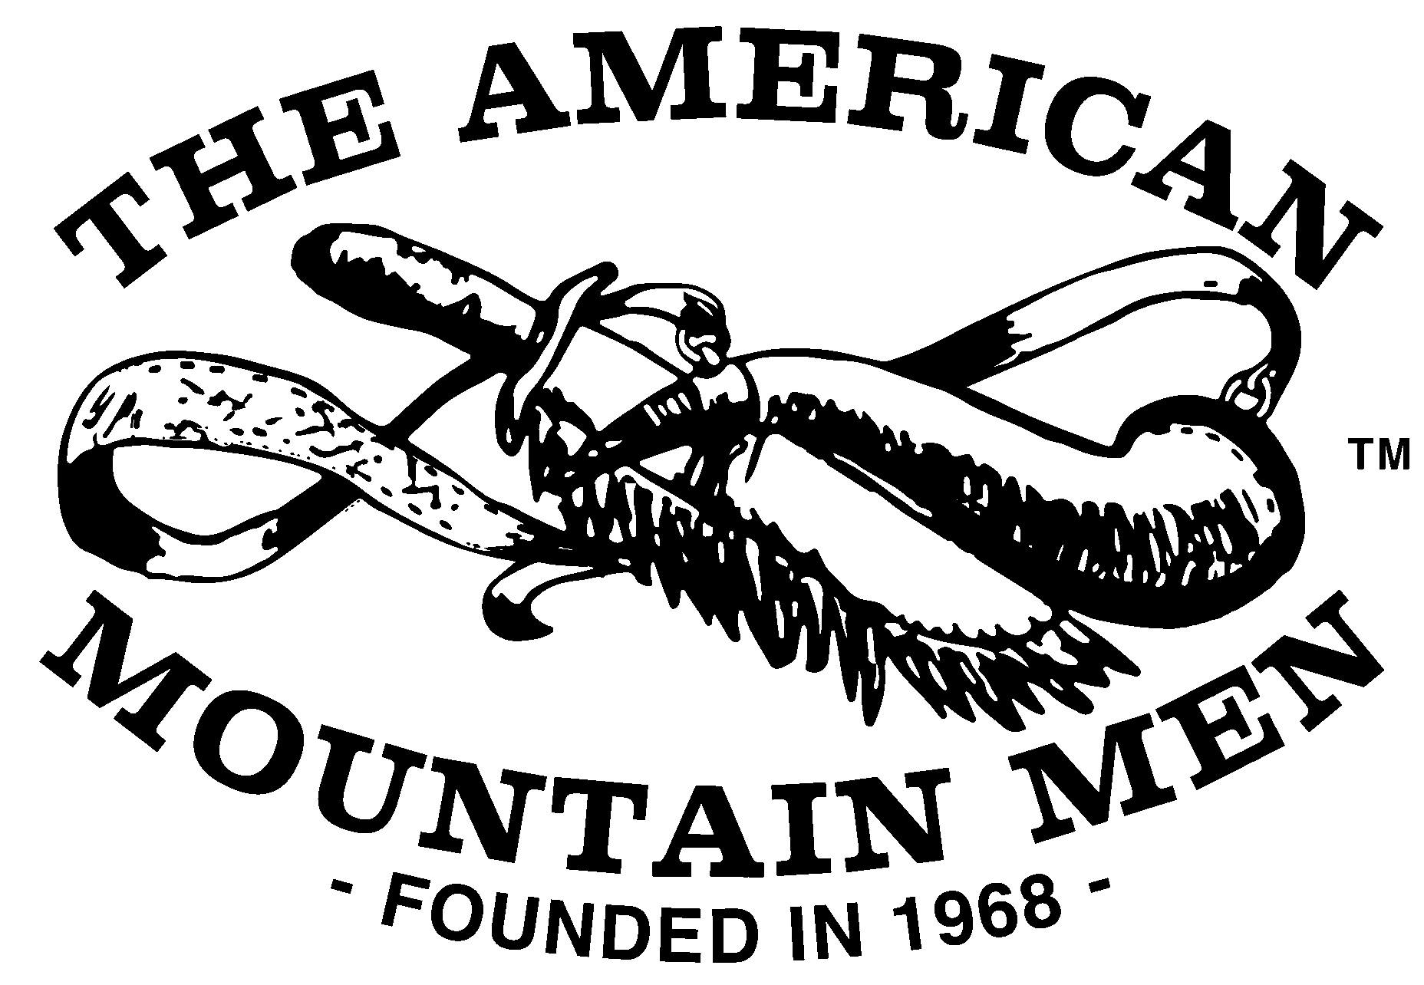
Probationary Application Form
Print the following

Name___________________________________________________________________Age______________

Address___________________________________________________________________________________

City________________________________________State_________________________Zip______________

Phone number including area code___________________________Email______________________________

If you have earned a nickname, please print it here_________________________________________________

I have read the Code and Objectives of the American Mountain Men and I can truthfully say that I understand and agree with them. I certify that I have a muzzle-loading firearm (or Indian bow) and all the necessary equipment for its care and feeding. I have a keen and sincere interest in the history of the fur trade and in primitive activities. It is my intention to hand make all my gear and clothing from authentic researched patterns, though I may barter and trade for a portion of these materials in true Mountain Man fashion, providing the goods received are of this same high quality. I understand that, during my first year with the American Mountain Men, I am expected to completely outfit myself as a Mountain Man, including my clothing, hunting pouch, powder horn, knife, bedroll, fire steel, head gear and moccasins. I agree not to participate in any activity of the American Mountain Men without this gear unless I have the permission of all other participating members, or the activity is a special class just for those of probationary status. I shall increase my knowledge of primitive survival skills, hunting skills and the skills required of a trapper. I understand that my first year is probationary and that my acceptance will depend on my certification that I have fulfilled the requirements, lived by the Code of the Mountains and worked toward the fulfillment of the Association Objectives.

Signature___________________________________Date______________AMM Party___________________

For Sponsoring Members and Office Use Only

1.___________________________card #_________Degree_____________________Date_________________
Party Booshway

2.___________________________card #_________Degree_____________________Date_________________
Signature of sponsor

3.___________________________card #_________Degree_____________________Date_________________
Signature of sponsor
Notice: Please send first year’s dues of $35 with this form, plus $5 application fee. Total = $40.00

Recommended by Brigade Booshway_______________________________________Date________________

Approved by Western/Eastern Segundo_____________________________________ Date________________

Received by the Chief Clerk______________________________________________Date_________________
Instructions
- Check to see all requirements are met.
- Fill out your part of this form and sign your mark.
- Get the necessary sponsoring signature(s) required.
- Attach signed letter(s) of Nomination from Sponsor(s) (see page 2).
- Attach signed letter of Introduction from Prospective Applicant
- Attach a check or money order for the first year’s dues, made payable to the American Mountain Men.
- Mail to your Brigade Booshway.

Methods of and Requirements for acceptance into membership (By-Laws Art. I)
- Membership in this association is by invitation only. Invitations to join will be issued only after the prospective member has:
- Been nominated by at least two (2) members holding Regular membership, Gray Beard membership or a combination of both, or by one (1) member holding Hiveranno membership.
- Been interviewed IN PERSON by the member(s) making the nomination.
- Been approved by the Territory Segundo.
- To be eligible for membership a prospective member must:
- Be eighteen (18) years of age or older.
- Have at least one muzzle-loading firearm with fixed sights or one hand made bow of a type and style used by American Indians. Said bow must have a pull of no less than thirty (30) pounds.
- Have made at least a partial study of the lives and methods of the Mountain Men during the 1800-1840 era.
- Show that he is willing to take an active part in the activities of the association.
- All nominations must be in writing, listing what is known of the prospective member (interest, experience, etc.) plus any other interest which will help determine eligibility all letters of nomination must have printed on them the name, card number, membership type, and state of member(s) making nomination. At least one member making the nomination must sign the letter.
- All nominations must be reviewed and recommended by the Brigade Booshway, then approved by the Territory Segundo. The nominee shall be accepted as a probationary member on the Territory Segundo’s approval.
- The association Capitaine may approve nominees in place of any Segundo. All Foreign members must be approved by the association Capitaine.

AMM Code
- I shall at all times consider a man's private life none of my business unless he wishes to make it so.
- I shall at all times strive to be a self-reliant individual, asking for help only if and when it is necessary.
- I shall at all times consider my word a sacred trust, a bond which is not to be broken.
- I shall at all times respect the personal property of other members, considering thievery an act deserving contempt.
- Before entering any camp or lodge I shall first make my presence known, then enter only if invited.
- I shall at no time fire any firearm in camp or give any other false warning of impending danger.
- During any survival situation, I shall be willing to divide any food and water I have and give any other assistance to people found in need.
- I shall take from nature only what I need or can actually use, practicing good conservation of our native wilderness and wildlife.
- At any association activity I shall follow the rules set forth by the Booshway in charge or leave of my own free will.
- I shall at all times strive to improve myself, my wilderness abilities and my knowledge of nature's law.

AMM Objectives
- The specific and primary purpose is to establish and maintain a permanent association for research into and study of the history, traditions, tools, mode of living, etc., of the trappers, explorers, and traders known as the Mountain Men.
- Further purposes are:
- Establish and maintain a permanent museum and research center to house and make available books, artifacts, films, speakers, etc.
- To provide a means for the dissemination of information related to our purposes and objectives.
- To provide a continuous program of living history.
- To teach the skills and help develop the abilities which were actually needed and used by the original Mountain Men.
- To help preserve the right of all free men to keep and bear arms.
- To help preserve our native wilderness and wildlife by teaching and practicing realistic conservation.
- To help establish brotherhood and trust between our members. To help our members find deep affinity with nature that is a basic and necessary trait of all true Mountain Men.

